Perform join optimizations in hive

Creating table empl and loading the data
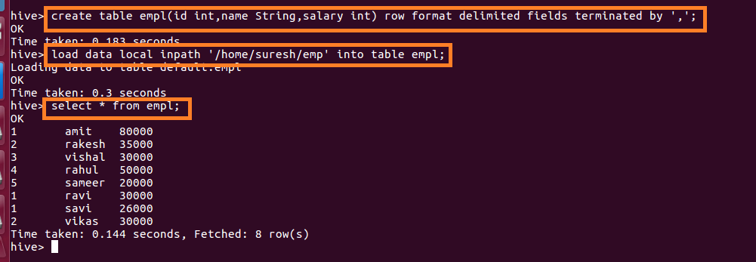

Creating table dept and loading the data
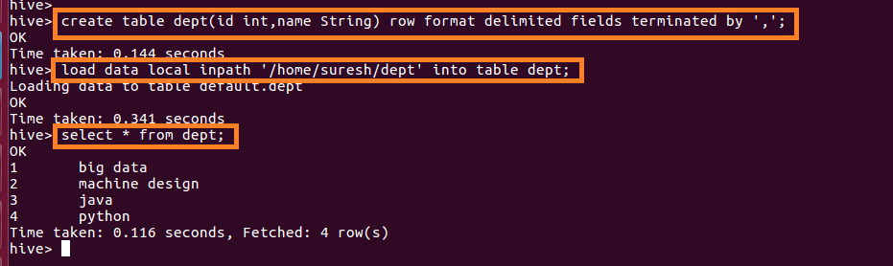

Join table ordering (Largest table last)
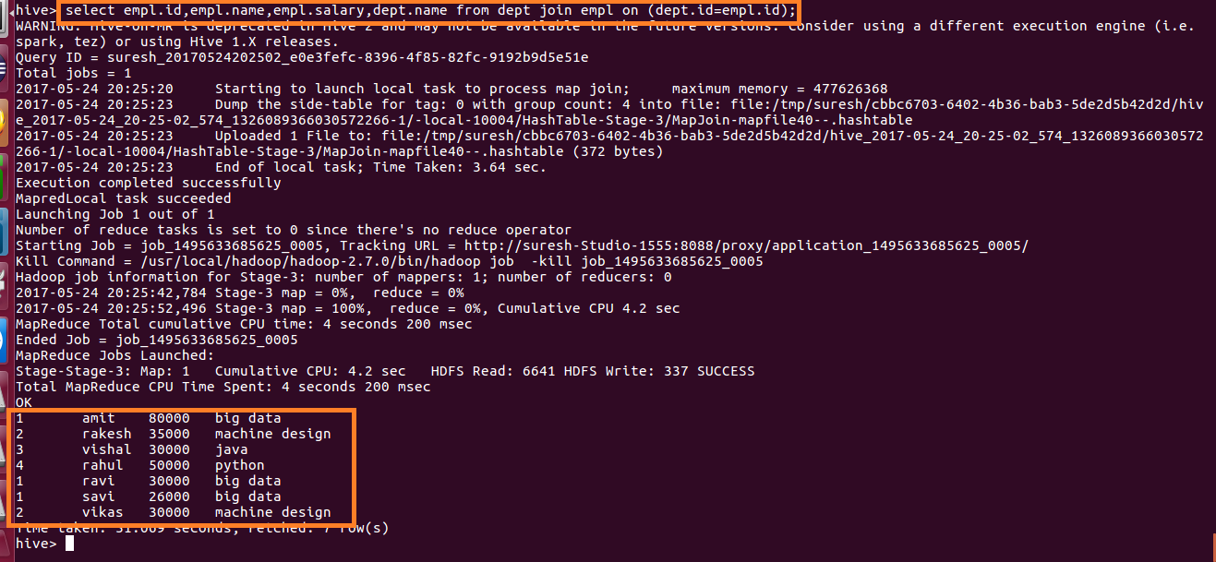

Map Side Join:
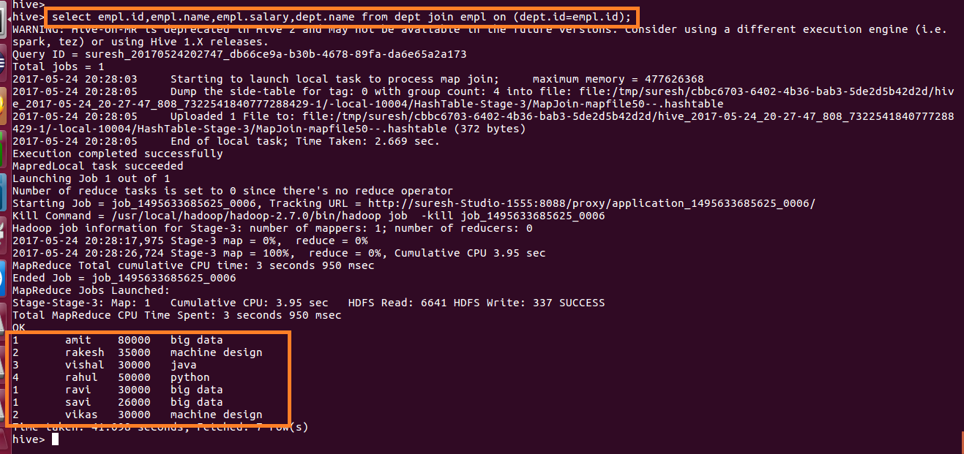

Sort-Merge-Bucket (SMB) Map Join:
Creating bucketed tables:
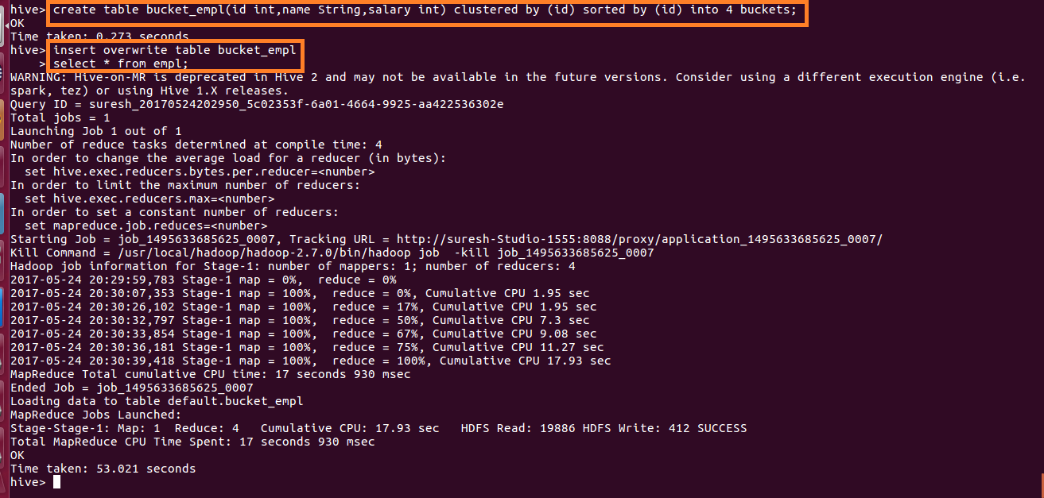

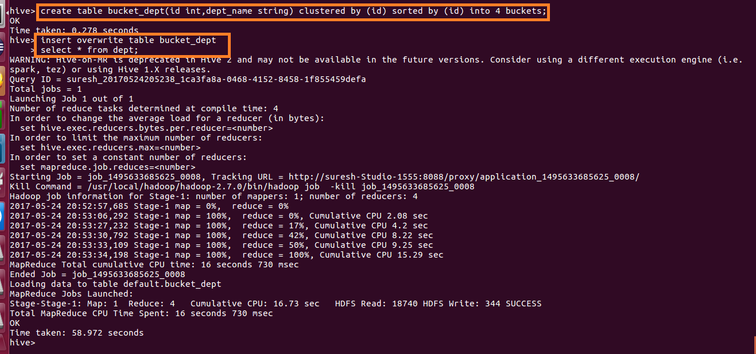

Performing SMB Map Join
